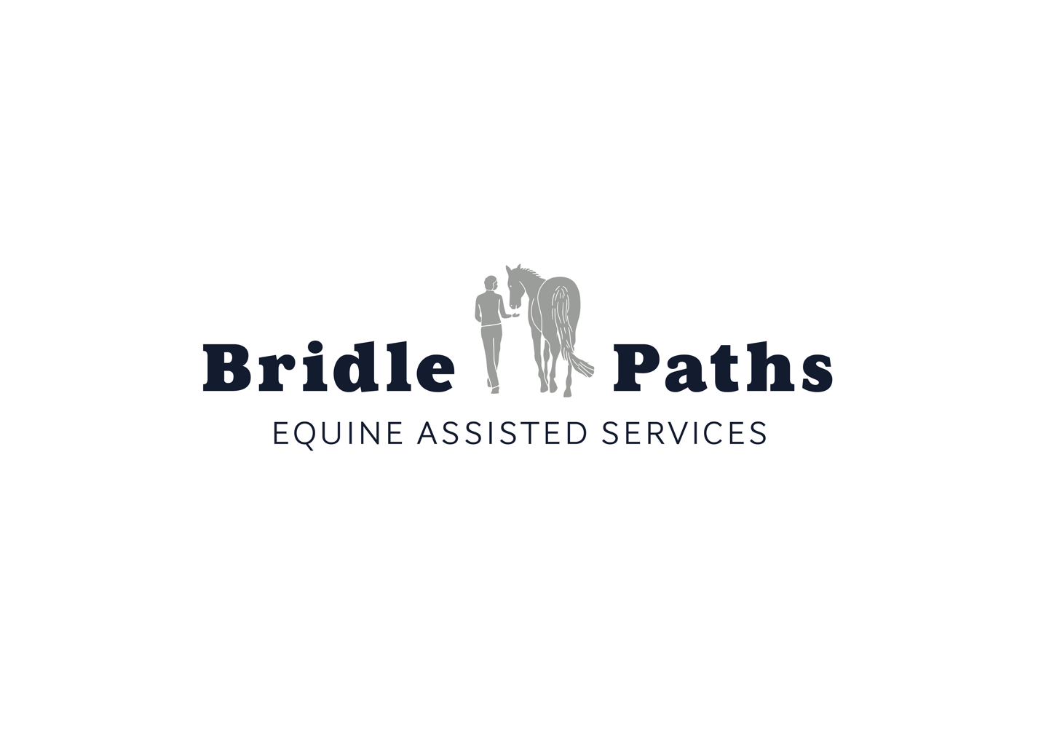

Bridle Paths Volunteer Manual

Contact Information

Website: www.bridlepathsva.org
Phone: 571-216-9089
Email: bridlepaths@gmail.com
Facility Address: Stone Horse Farm, 43247 Spinks Ferry Road, Leesburg, VA 20176
Mailing Address: 17169 Spring Creek Lane, Leesburg, VA 20176

Table of Contents

Program Description. . . . . . . . . . . . . . . . . . . . . . . . . . . . . . . . . . . . . . . . . . . . . . . . . . . . . 2
What is therapeutic riding?. . . . . . . . . . . . . . . . . . . . . . . . . . . . . . . . . . . . . . . . . . . . . . . 3
What are equine assisted psychotherapy and equine assisted learning?. . . . . 4
Confidentiality. . . . . . . . . . . . . . . . . . . . . . . . . . . . . . . . . . . . . . . . . . . . . . . . . . . . . . . . . . . 5
Volunteer Eligibility. . . . . . . . . . . . . . . . . . . . . . . . . . . . . . . . . . . . . . . . . . . . . . . . . . . . . . 6
Barn Rules. . . . . . . . . . . . . . . . . . . . . . . . . . . . . . . . . . . . . . . . . . . . . . . . . . . . . . . . . . . . . . . 8
Proper Barn Attire. . . . . . . . . . . . . . . . . . . . . . . . . . . . . . . . . . . . . . . . . . . . . . . . . . . . . . . .9
Horse Body Language. . . . . . . . . . . . . . . . . . . . . . . . . . . . . . . . . . . . . . . . . . . . . . . . . . . .10
Equine Senses. . . . . . . . . . . . . . . . . . . . . . . . . . . . . . . . . . . . . . . . . . . . . . . . . . . . . . . . . . . 11
Handling the Horses. . . . . . . . . . . . . . . . . . . . . . . . . . . . . . . . . . . . . . . . . . . . . . . . . . . . .15
Barn Work. . . . . . . . . . . . . . . . . . . . . . . . . . . . . . . . . . . . . . . . . . . . . . . . . . . . . . . . . . . . . . 21
Unmounted Activities Checklist. . . . . . . . . . . . . . . . . . . . . . . . . . . . . . . . . . . . . . . . . .26
Grooming Portion of the Program. . . . . . . . . . . . . . . . . . . . . . . . . . . . . . . . . . . . . . . 27
Tack and Equipment. . . . . . . . . . . . . . . . . . . . . . . . . . . . . . . . . . . . . . . . . . . . . . . . . . . . 28
Lesson Portion of the Program. . . . . . . . . . . . . . . . . . . . . . . . . . . . . . . . . . . . . . . . . . 31
Equine Terms Glossary. . . . . . . . . . . . . . . . . . . . . . . . . . . . . . . . . . . . . . . . . . . . . . . . . 36

Program Description

Bridle Paths is a nonprofit organization that offers strength, support, and healing to individuals and families through safe, effective, and high-quality equine-assisted activities and therapies. The Bridle Paths program provides a continuum of services that is unique in the Northern Virginia area. We provide therapeutic horseback riding, equine-assisted psychotherapy services, and equine-assisted learning programs for individuals and families faced with physical, cognitive, psychological, and emotional needs. By combining the ground-based activities of equine-assisted psychotherapy and equine-assisted learning and the mounted and horsemanship activities of therapeutic riding, Bridle Paths programs can benefit both families and the community.

The program serves those with a wide variety of needs and diagnoses, including attention deficit disorder, autism spectrum disorders, brain injuries and physical disabilities, cognitive impairments, post traumatic stress, anxiety and depression, seizure disorders, genetic disorders, and experiences of abuse and trauma. Our staff has particular experience in working with families coping with the challenges of a special needs diagnosis, and with at-risk adolescents and young adults and their families.

Bridle Paths is a member of the Professional Association of Therapeutic Horsemanship (PATH) Intl. and the Equine Assisted Growth and Learning Association (EAGALA), and our staff members are trained and certified by those organizations.

What Is Therapeutic Riding?

The therapeutic riding program at Bridle Paths offers adapted riding instruction to children and adults with physical, cognitive, behavioral, and emotional needs. In addition to mounted instruction, lessons can also incorporate instruction in grooming, horse care, and other horsemanship matters. Where appropriate, we may place riders into group lessons to facilitate the accomplishment of social and communication goals. Lessons are staffed with an instructor certified by PATH, as well as enough volunteers, who act as horse leaders and sidewalkers, to conduct the lesson safely. Each of our therapeutic mounts is carefully selected for temperament, training, and quality of movement, and is generally nonplused by the sights, sounds, and reactions of riders. We recognize the importance of families' involvement in the daily lives and activities of individuals with special needs, and we work very hard to ensure that our program is a warm, welcoming, and accepting place for everyone. The focus in these sessions is the provision of emotionally-attuned instruction and the cultivation of relationship and connection between client and horse, and with program staff and volunteers as well.

Through participation in programs at Bridle Paths, clients will recognize the myriad therapeutic benefits of the horse. In addition to the immediate benefit that riding affords for balance, strength, and coordination, clients benefit from the sensory, tactile, motor planning, and social and communication experiences that horses provide. Clients can enjoy improved health and mobility, enhanced self-confidence and self-esteem, and increased patience and reflection. Additionally, clients can cultivate positive leadership and problem-solving skills, regain trust and focus, and enjoy renewed hope for their futures through working with horses. The program's community of clients, families, volunteers, therapists, teachers, and patrons celebrate the cadence of movement, relationships, and caring that benefits all participants. We share the moments, big and small – a shared understanding between volunteer and rider, the optimism born of a newfound relationship with horses, the thrill of attaining a riding prize, or the satisfaction of sitting or walking unassisted – that make a real difference to individuals and to our community.

What are Equine Assisted Psychotherapy and Equine Assisted Learning?

Equine-assisted psychotherapy (EAP) is an experiential therapeutic approach that addresses treatment goals using collaborative efforts among a horse professional, a licensed therapist, the horse, and the client. Each client-driven session includes hands-on activities with the horses, as well as processing of feelings, behaviors, and patterns designed to enable clients to learn about themselves and others. Clients interact with the horses on the ground and use nonverbal communication, problem solving, and creative thinking to address a variety of mental health and developmental issues. EAP is solution-focused and is considered a short-term or "brief" approach designed to activate the client's own healing resources. Bridle Paths staff partners with therapists from the Gil Institute for Trauma Recovery and Education, and with Beth Ratchford, LCSW, in providing EAP services. EAP sessions are confidential and do not require volunteer assistance.

Bridle Paths periodically conducts Equine-Assisted Learning (EAL) sessions as well. These sessions may require volunteer assistance on occasion. EAL is an experiential learning approach that promotes the development of life skills for educational, professional and personal goals through equine-assisted activities. Bridle Paths has provided EAL sessions for school groups, individuals with traumatic brain injuries and experiences of trauma, veterans and military families, and corporate groups. These EAL groups emphasize the cultivation of communication, connection, trust, and relationships.

Confidentiality

Bridle Paths recognizes the sensitivity of our clients’ records and the right of each participant to privacy. Our clients are assured that their individual files are kept in the strictest confidence. All written client records shall be maintained by the program director and shall not be made available to other clients, volunteers, or board members except on a strict need-to-know basis. Volunteers assigned to a client shall be informed about the client’s medical background only as needed to ensure safe mounting and riding of the client. All information (written and verbal) about participants at Bridle Paths is confidential and will not be shared with anyone without the express written consent of the participant and his or her parent/guardian in the case of a minor.

- Bridle Paths shall preserve the right of confidentiality for all participants in the program.
- Participants at Bridle Paths shall keep confidential medical, social, referral, personal, and financial information regarding participants and family members.
- Persons subject to the confidentiality policy include
  - Full- and part-time staff
  - Independent contractors
  - Temporary employees
  - Volunteers
- Specific written consent of the participant/guardian is required prior to the disclosure of information to outside agencies or individuals.

Volunteer Eligibility

- Volunteers typically have a minimum age of 14. Junior volunteers between the ages of 8 and 13 are permitted to do barn work, but not handle the horses or be involved in lessons. The program director may choose to make special exceptions based on an individual’s experience, level of maturity, and horse background.
- Due to the inherent risks in therapeutic riding and the sensitive nature of the clients, the instructional staff maintains the right to assess whether a volunteer is able to participate in the demands of the program. If it is found that the volunteer does not have the ability to safely participate as a sidewalker or horse leader in the program, they will be given the option to participate in administrative or barn work.
- Situations that may indicate a volunteer’s inability to perform the above functions include:
  - Repeated difficulty with following directions;
  - Inability to physically participate in the demands of the program (e.g., poor range of motion or pain in the shoulders, poor physical condition, etc.)
  - Inattention to the demands of the therapy setting (horse leading techniques, not responding to directions, unsafe horse handling practices, distracting the rider during the lesson);
  - Repeated tardiness or lack of dependability.
- Volunteers should be committed to regular attendance and to arriving at an appointed time
- Volunteers should be willing to learn how to groom and tack horses in preparation for therapeutic riding sessions.
- Volunteers should be able to take directions from the program director, lead volunteer, or barn manager
- Volunteers should dress appropriately for the therapeutic riding session and follow guidelines for dress (more information on page 8).

Conduct

All staff members, volunteers, and clients of Bridle Paths are expected to adhere to standards of conduct acceptable to the program. Any allegations of inappropriate behavior towards others or failure to follow established safety standards will be cause for termination from the program. Examples include substance abuse, sexual harassment, mistreatment of horses, disrespect for property, and smoking in off-limits areas. It is also expected that volunteers do not use or check cell phones during the lesson or when working with a rider. If it becomes necessary to check your phone during a client session, have another volunteer step in to assist the client before doing so.

Dismissal of Volunteers

All Bridle Paths personnel, volunteers, and guests of the program must adhere to the rules of the management of this facility. The Barn Safety Rules can be found on page 7.

Barn Safety Rules

- All participants working with any horse must sign Bridle Paths’ waiver prior to participating and give to Bridle Paths (BP). If participant is under 18 years of age, parent/legal guardian must sign waiver.
- Visitors (anyone other than BP staff, trained volunteers, and riders with appropriate supervision) are not allowed in stalls or turnout areas. Riders may enter stalls ONLY with appropriate staff and volunteer supervision. Visitors may not interact with the horses unless they have signed the waiver or are under proper volunteer/staff supervision.
- Everyone MUST wear a properly fitted and ASTM/SEI approved helmet when mounted and grooming.
- No smoking in or around the barn.
- No drinking alcoholic beverages or use/possession of illegal substances on property.
- Jeopardizing the safety of horse or human in any way will not be tolerated.
- Always clean up after yourself and your horse.
- Do not feed horses (including treats or hay) without permission from BP, or make adjustments to feed without discussing with BP.
- Do not wander around personal property unless accompanied by BP personnel.
- Volunteers and staff must wear appropriate shoes/boots while working around the horses.
- All injuries, accidents, or damages must be reported to BP immediately.
- Disrespect for others will not be tolerated.
- Do not ride horses in the barn aisle.
- Please refrain from using profanity.
- Refrain from engaging in disruptive behavior or making sudden or loud noises that may frighten animals.
- No running around the horses.
- Please do not climb, hang or swing on the gates.

If you aren’t sure or don’t know, PLEASE ASK!

Proper Barn Attire

DO: wear closed toed shoes (e.g., sneakers or boots)
DON’T: wear open toed shoes (e.g., sandals or flip-flops)

DO: wear fitted clothing that you are comfortable in (e.g., a t-shirt or sweatshirt)
DON’T: wear very loose clothing (e.g., a very flowing top)

DO: wear appropriate length shorts, should be below your fingertips
DON’T: wear short shorts or skirts

DO: wear clothing you do not mind getting dirty
DON’T: wear hanging jewelry

***When dressing for the barn, it is important to keep in mind the individuals you will be working with. Some clients may be sensitive to heavy use of perfume and/or other scented products, so be aware of their needs when preparing to attend the barn.

Horse Body Language
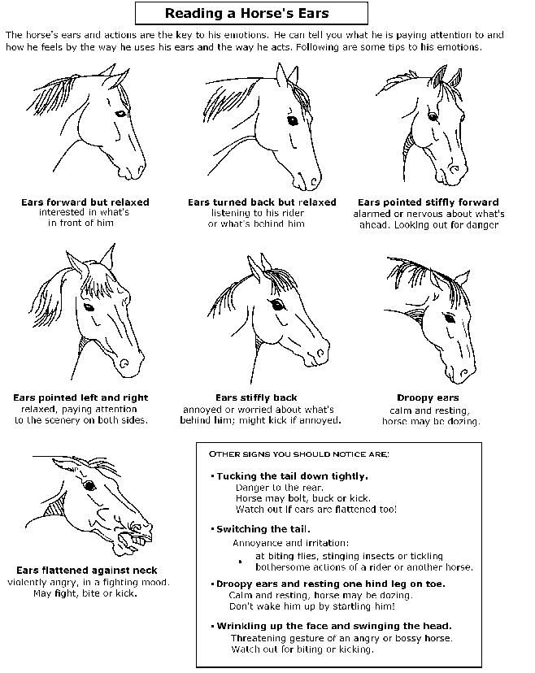
Equine Senses

When developing relationships and working with horses, communication is key. It is critical to provide a safe environment in a therapeutic riding setting. Beginning a process of understanding the horse’s senses, instincts and implications is a step in predicting behaviors, managing risks, and increasing positive relationships.

Smell: The horse’s sense of smell is thought to be very acute and it allows him to recognize other horses and people. Smell also enables the horse to evaluate situations.

Implications
- Allow horses the opportunity to become familiar with new objects and their environment by smelling.
- It is recommended that treats are not carried in your pocket since horses may desire to go after them.
- Volunteers should be discouraged from eating or having food in the arena.

Hearing: The horse’s sense of hearing is also thought to be very acute. The horse may also combine his senses of hearing and sight to become more familiar with new or alerting sounds. “Hearing and not seeing” is often the cause of the fright/flight response. Note the position of the horse’s ears (pictures on page 9). Forward ears communicate attentiveness and interest. Ears that are laid back often communicate that they are upset and/or showing aggression towards another horse or person.

Implications
- Horses are wary when they hear something but do not see it. If your horse is acting nervous, talk to him in a quiet and calm voice for reassurance.
- Avoid shouting or using a loud voice. This can be frightening to a horse.
- Watch your horse’s ears for increased communication. Stiffly pricked ears indicate interest. Drooping ears indicate relaxation, inattentiveness (easily startled), exhaustion, or illness. Flattened ears indicate anger, threat, or fear. Ears flicking back and forth indicate attentiveness or interest.

Sight: The horse’s eyes are set on either side of the head; there is a good peripheral vision, but poorer frontal vision. A horse focuses on objects by raising and lowering its head. The horse’s visual memory is very accurate. Horses are thought to see quite well in the dark, due to the large size of their eyes. There is still controversy as to whether or not horses see in color.

Implications
- The horse may notice if something in the arena or out on a trail is different. Allow the horse an opportunity to look at new objects. Introduce new props that the horse may be unfamiliar with.
- The horse has better peripheral vision; consider a slightly looser rein, enabling him to move his head when taking a look at objects.
- Although the horse has good peripheral vision, consider two blind spots: directly in front and directly behind. The best way to approach a horse is to his shoulder. It may startle him if you approach from behind or directly in front. The horse may be unable to see around the mouth area, which is a safety consideration when hand feeding.

Touch: Touch is used as a communication device between horses and between horses and people. Horses are sensitive to soft or rough touch by a person’s hands or legs.

Implications
- Handlers should treat horses gently but firmly.
- Each horse has sensitive areas, and it is important to be familiar with them (ie. flank and belly areas).
- Watch rider leg position. Riders may need appropriate assistance to reduce a “clothespin” effect with their legs. Ask the instructor what is the best handling technique.
- Horses will often touch or paw at unfamiliar objects. For example, a horse may paw at a bridge or ground pole before crossing it.

Taste: Taste is closely linked with the sense of smell and helps the horse to distinguish palatable foods and other objects.

Implications
- Taste is closely linked with smell and touch; therefore a horse may lick or nibble while becoming familiar with objects and people. Be careful, as this could lead to possible biting.

Sixth Sense: Horses do have a “sixth sense” when evaluating the disposition of those around them. Horses can be hypersensitive in detecting the moods of the handlers and clients. A good therapy horse is chosen for his sensitive response to the client. At times there may exist a personality conflict between handlers and horses. It is important to the inform the instructor if you’re having a difficult time relating or getting along with a particular horse.

The Horse’s Lifestyle: In addition to understanding the horse’s sixth sense, we need to appreciate and increase our awareness of the horse’s lifestyle. This will assist us in responding appropriately to his reactions and situations

Flight as a Natural Instinct: Horses would rather turn and run away from danger than face and fight it.

Implications
- At a sudden movement or noise, the horse might try to flee. Speak to the horse calmly.
- A frightened horse that is tied up or being held tightly might try to escape by pulling back. Relax your hold or untie him quickly and usually he will relax. Be sure not to stand directly behind the horse.
- If flight is not possible, the horse could either turn to kick out or face the problem and rear, especially in a tight area like the stall. A halter with a lead rope may assist with maintaining control while working around the horse in a stall.
- If a horse appears to be frightened or fearful (note the position of the horse’s ears in pictures on page 9), it may be helpful to allow a more experienced horse to lead.
- Most of the horses chosen to work in a therapeutic setting have less of an instinct to flee. The horse may look to you for reassurance. It is helpful if the volunteer remains calm and talks to the horse in a soothing voice.

Herd Animal: Horses like to stay together in a herd or group with one or two horses dominant, with a pecking order amongst the rest.

Implications
- Be aware that a horse may not like being alone. This is a consideration when horses are leaving the arena or a horse loses sight of the others while on a trail ride.
- Be aware that if the horse in front of a line is trotting or cantering, the horse that is following may also attempt to trot or canter.
- If one horse spooks at something, the surrounding horses may also be affected.
- For safety, it is recommended to keep at least one horse’s length between horses when riding within a group to respect the horse’s space and pecking order.

Note: Being aware of horse behaviors is one of the best safety precautions that can be used in our facility. Knowing how to read your horse can prevent an accident and increase the quality of your mutual relationship.

Handling the Horses

Parts of the Horse
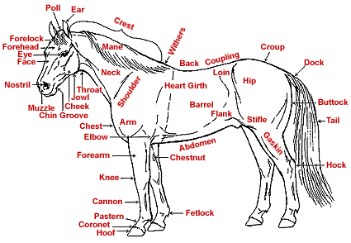

Greeting the horse: In order to correctly introduce yourself to the horse, you want to hold your hand out flat and put it near the horse’s nose. We refer to this as the “horse handshake” and it is important to have your hand where the horse can see it so you do not immediately reach right into its blindspot.

What do I do if a horse pins its ears back at me when I offer it my hand?
Proceed with caution. Slowly try and introduce yourself. Do not force your hand to the horse’s nose, simply slowly bring your hand near its mouth until it accepts the offer and sniffs your hand.
Barn safety when horses are in the aisle: When a horse is on the cross ties, it is important to respect its space in order to maintain a safe environment for the people and the animals.

What do I do if a stranger comes in and starts touching the horse?
Respectfully ask the person to step away from the horse. The program horses are similar to service dogs and it is important that people are respectful of their space. If someone comes right in and begins petting the horse, respectfully ask them not to touch the horses.

What if another horse is coming in and there is a horse in the aisle?
Take a cross tie off of one side and then ask the horse to move over to let the other horse by. You do this by saying “over” and pressing a finger right behind where the girth would be. Make sure to stand by the horse to make sure the other horse can safely pass with a fair amount of distance between the two horses.

Will a horse kick me if I walk behind it?
Since a horse has two blind spots, one behind them and another in between their eyes, it is important not to surprise them when coming up from behind. If possible, always try to walk in front of the horse where the eyes are, and encourage the clients to do the same. If you need to walk behind a horse, place a hand on the horse’s haunches to alert it that you are there and continue talking or patting while you walk around the horse’s back legs.

Horse Space Bubbles: As a general rule of thumb, it is a good idea to keep at least one horse length (approximately 8 feet) between your horse and the horse in front of you. It is important to be conscious of which horses know each other and are acquainted (based on whether they go out in the field together) and understand the horse hierarchy. If two horses do not know each other well, it is important to give them a larger bubble for safety reasons.

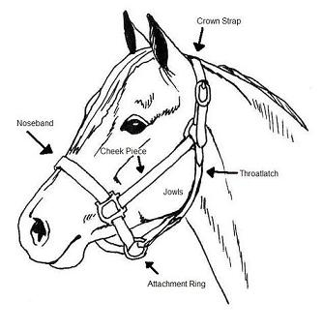
Taking a horse in and out of the stall: While handling a horse, it important that the halter is on and secured and the lead rope is attached properly.

Where can the halters and leadropes be found?
Halters and leadropes can be found hanging on the stall door of each respective horse. Extra lead ropes can be found in the tack room hanging on the wall adjacent to the door. Some horses may require a leadrope with a chain but a chain is never acceptable to use in a lesson or with a bridle.

Where can the crossties be found?
There are three sets of crossties throughout the barn aisle hanging from the wall.

Tips and Tricks
- Make sure to open the stall door ALL the way so that the horse may safely enter or exit the stall without hitting the door.
- Never attach a lead rope or a cross tie to the bit on a bridle.
- Always make sure the space you are entering is clear of clutter and people. Crowding horses can cause them to react out of fear or panic.
- Always hang the crossties back up when they are not being used so that they are not dangling on the ground and stepped on.

Taking a horse in and out to the field: When it is time for the horses to go out, either during the day or night depending on the season, you need to be careful and be attentive to their body language. They may be excited when going out for the night or coming in for breakfast.

How do I know which field to put the horse(s) in?
A chart on the whiteboard between the feed room and the tack room remains updated with where the horses go in the field. The horses’ names will appear in the appropriately marked field on the diagram.

Tips and Tricks
- Always keep the halter on when turning a horse out and take the halter off when they are in the stall.
- Remember that the gates need to be securely closed after a horse is in the stall and the chain needs to be clipped around the gate to ensure safety.
- The gate at the bottom of the field should always be closed to ensure the safety of the horses.
- Always check the horses for cuts and scrapes when it comes in the field. An open cut can become infected if not treated in a timely manner.
**If a horse has a cut or scrape, inform a volunteer leader or the program director so that they may tend to it properly. The equine first aid kit is in the feed room.

Grooming the horse before the rider arrives: It is important to make sure that the horse is clean before mounted activities. The rider is not always capable of cleaning the horse fully so we do a “pre-grooming” before the rider arrives.
- Curry comb: a small round brush that you use by brushing in circles on the horse. This helps all the dirt and hair come up to the surface to be brushed away later. This brush can be used on the neck, stomach (or barrel), and back end.
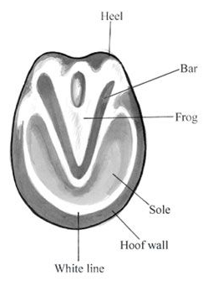
- Hard Brush: a hard brush usually with colored bristles that can be used to brush away the dirt and hair brought up by the curry comb. Use this brush in the direction that the hair grows in. Can be used in all the same places as the curry comb.
- Soft Brush: a softer brush with neutral bristles. Use this brush in the direction that the hair grows in. Can be used in all the same places as the hard brush but also on the legs and belly.
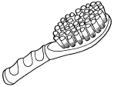
- Hoof Pick: used to clean the hooves. Make sure to avoid the V in the middle of the hoof (or the frog) and brush until you can see the foot. Oftentimes, riders will need help picking up the foot.
- Mane/Tail Brush: used to brush the mane and tail

Tips and Tricks
- Keep an eye on the time and be aware of when a horse is being used throughout the day so you can groom the horses being used earlier first.

Keeping an eye on the riding schedule: Being aware of when students come and when specific horses are needed is necessary to keep the lesson schedule running smoothly.

How do I know what the lesson schedule is?
An electronic copy of the schedule is emailed to volunteers weekly. In addition to this, there is always a printed copy of the schedule hanging on the boards by the tack room which lists each rider’s time slot, their lesson horse, and required tack.

Tips and tricks
- If the horse needed for the lesson is outside in the field, it’s important to bring the horse in at least fifteen minutes prior to the lesson so that it may be pre-groomed or groomed and tacked and ready for the student.
- If the schedule specifies that the student rides first, then the horse must be groomed and tacked up in a timely manner before the arrival of the student.
- If the student grooms first, the lesson horse should be awaiting its rider in the cross ties with its grooming kit nearby.

Feeding the horses: Many of the riders bring treats (ie. apples, carrots, etc.) to feed the horses after their lessons. Treats can be found either in the feed room or in the fridge up in the observation area.

Proper hand position for offering treats
Tips and Tricks
- Make sure that any feeding of treats is strictly supervised. Any treats fed by hand must be offered with a flat palm.
- Some horses must be offered treats only in a bucket for safety reasons. Check with program staff or volunteer leaders for further information.
- Some students prefer to drop the treats into a horse’s stall feeder. This is perfectly fine, just supervise them as they make their rounds to every stall and ensure that the horse is respectful in waiting for the treat to land in his bucket.

Tacking the horse up: Tacking a horse up is when one puts on the riding equipment (ie. the saddle and the bridle) to prepare the horse for a lesson. More information about equipment can be found on page 28.

How do I learn to tack up a horse?
Before tacking up a horse at Bridle Paths, EVERY volunteer will get a tutorial from an experienced volunteer at Bridle Paths. While there are many different techniques for tacking up, it’s important to follow procedures as specified by Bridle Paths staff and volunteer leaders to ensure consistency and comfort for program horses.

Tips and tricks
- If you do not feel comfortable tacking up a horse, ask for assistance from a leader who will then assist you in doing so.
- Horses should be tacked up promptly as to not delay the lesson schedule.
- Every horse requires different tack depending on the rider so make sure to check the schedule and be aware of specifications.

Barn Work

What can I do when I’m not working in a lesson?

Cleaning stalls: Cleaning the horse’s stalls is a vital part of everyday work. In order to make sure the horse has a clean and safe environment, it is important to make sure that they have a clean stall to come into everyday.

Where can I find the pitchforks and wheelbarrows?
The pitchforks and wheelbarrows are in a small open area past the tack room on the right. If you pass the hay, you’ve gone too far. If the wheelbarrow is full, check with a volunteer leader to see whether you can proceed to empty it and use it for stall cleaning.

How do I know when a stall is clean?
Although you do not need to get every strand of hay out, you want to make sure that you have cleaned out all of the waste. In addition to cleaning out all the poop, make sure to dig and look for the pee. Oftentimes, it is difficult to see where a horse has peed so you need to dig in order to find the wet spots.

How do I know whether or not to take out the hay if there is any left in the stall?
If there is any waste in the hay, it is important to take it out of the stall. If the hay is dry and consolidated into one area, you may leave it.

What is the next step after the stall is clean?
After all the waste is cleared out, it is important to sweep the area in front of the feed/water buckets and in front of the stall door so the horses do not track bedding into the aisle of the barn. You should sweep back the bedding about a foot and a half and make sure that the area where we leave the hay is clear.

Tips and Tricks
- Make sure to shake out all excess bedding when scooping out manure to conserve as much bedding as possible.
- If the horse is in the stall when you are cleaning it, make sure that the wheelbarrow is fully blocking the stall entrance before entering the stall to clean it.
- Make sure to turn over all the bedding and pull down the banking from the sides of the stalls to check for stray bits of manure.
- Turn the fans off before cleaning the stalls to avoid getting bedding in eyes.
- If a volunteer is uncomfortable cleaning a stall with the horse in it, then the volunteer may put the horse in the crossties.

Bringing in bedding: Making sure that the stalls have enough bedding is a vital part of barn work. It makes the stalls comfortable for the horses and easier to clean.

How do I handle the tarp that covers the bedding?
Just lift up a small section of the tarp to get to the bedding. Do not attempt to take the whole tarp off of the pile of bedding. It is important to be conscious that the tarp does not blow up when a horse is in the arena because it might alarm them.

How much bedding should I put in the stall?
There should be enough padding so the footing is soft and cushioned when you walk on it and you cannot see or feel the ground. It is helpful to add additional bedding to the sides and back corners of the stall (known as banking) so it can be pulled down the following morning.

Tips and Tricks
- Get a running start with the wheelbarrow. The momentum helps to get the wheelbarrow over the stall threshold.

Cleaning and filling water buckets is vital to the health of a horse. This must be done daily to ensure a clean and available source of drinking water for the horses.

Where do I empty the buckets?
The buckets can be emptied either into an empty wheelbarrow and then dumped outside away from the walkways and in the grass. Individual buckets can be dumped directly outside into a grassy area.

What do I use to clean the buckets?
Scrubbing brushes can be found near the main hose by the arena entrance.

How do I know when the bucket is clean?
After dumping out the bucket, check to see if the interior of the bucket is slimy or discolored. If so, then use a brush to scrub away the slime and dirt and then rinse with water before returning it to the appropriate stall.

Where do I fill the buckets up?
Buckets can be filled up at the pump site by the indoor arena and then brought back to the appropriate stall. If the hose is attached to the pump, it may be pulled to the buckets inside the stalls.

Tips and Tricks
- Keep track of each water bucket; some horses require two. It’s important to the horse’s health that it does not share water buckets with other horses.
- Don’t forget to rinse out the bucket after it is scrubbed and before it is returned to the stall.
- Put the scrubbing brushes back after use.

Scrubbing outdoor waterers: The waterers outside are what the horses drink from then they go out in the field. It is important to keep them clean and scrubbed regularly so that the horses have access to clean water.

Where are the waterers located?
The waterers are outside in the fields a little ways away from the gate. They are located so there is one in between every two fields. There are four out in the large pastures and one in the smaller field across from the outdoor ring.

How do I clean the waterers?
Take a small scrubbing brush located near the hose as well as a bottle of apple cider vinegar. Once you reach the waterer, you need to unplug it so the dirty water comes out and then plug the hole where the water is flowing from so you do not waste water. Then, pour enough apple cider vinegar into the waterer so you can scrub the bottom and edges of the waterer (about two tablespoons).

Tips and Tricks
- Make sure to scrub until there is no residue in the waterer. To test this, you can use your hand and feel whether there are any slimy parts in the waterer.
- Make sure that you move the plug back to cover the original hole so that the water can flow into the space.

Sweeping: Keeping the aisle clean is an important part of maintaining the barn. A clean barn means a happy environment. Sweeping is another good way to engage the rider in his or her unmounted activities.

Where do I find the brooms?
The brooms and dustpans are located right next to the hose in front of the indoor arena.

Where do I put the waste?
You can empty the dirt into the trash can located by the main entrance or a wheelbarrow going out to the manure pile.

Putting tack and grooming kits away: It is important to keep a clear aisle for the safety and protection of horses, people, and equipment.

How do I know whose grooming kit or tack I am handling?
Each grooming kit has a label on the side saying which horse’s locker it needs to be returned to. Both the saddle and bridle have tags on them to indicate the horse it belongs to. The tack and grooming kits can be found in their respective lockers in the tack room.

What if a horse’s tack is not in its locker?
Check with a lead volunteer about where the tack may be. Under no circumstances should you use another horse’s tack on the horse. The saddles and bridles are fitted specifically to each horse.
Tips and Tricks
- Always place the saddle so that the front of it (the pommel) is facing the wall or the back of the cubby. Otherwise the saddle is more likely to fall off of the rack.
- Lay the saddle pad upside down and on top of the saddle so that it may air out if it is sweaty and dirty.
- Hang the bridle on a bridle rack by the crown piece (the top of the bridle) and the buckle on the reins. Bridles and reins should never touch the ground as they may get tangled in the legs of a horse or rider.
- Make sure the stirrups are properly run up before returning a saddle to its cubbies.

Working with students: Working hands-on with the students is an important part of our program. Volunteers are supportive and informed resources for the students.

What do I do if the student arrives early?
If the student arrives early, direct them upstairs towards the viewing room where they can wait for their timeslot.

What if the student becomes aggressive or hostile?
If the student becomes aggressive or hostile, speak calmly and try to address the problem. If the student becomes more hostile or upset, ask for assistance from a volunteer leader or the program director.

What if the student is ill or injured?
If the student is injured, notify a volunteer leader or the program director immediately. Move the student away from any horses and to a safe place where they can sit or lie down.

Tips and Tricks
- It’s crucial to remain calm, patient, and positive.
- Encourage the students to perform the best they can, but always be willing to help them.
- The First Aid kit is in the feed room.
- NEVER leave a student unattended.
- Stick to the schedule as closely as possible. This allows students to maximize their time working with the horses and allows the program to run smoothly.

Unmounted Activities Checklist

- The rider has used all the grooming tools and completed the grooming steps in the proper order (curry comb, hard brush, soft brush, hoof pick, mane and tail brush).

- The rider has assisted in putting the saddle pad(s) and saddle onto the horse and helped buckle the girth.

- The rider has assisted in adjusting the stirrups to the proper length.

- The rider has checked their horse’s stall to make sure that the horse has finished his/her grain meal, has water for the day, has hay for the day, has a mineral brick available, and has a clean stall (if not clean, the rider has helped scoop out waste).

- The rider has helped sweep up any dirt and/or waste left in the aisle.

Grooming Portion of the Program

Engage the rider when they first arrive: Sometimes, the rider may be nervous to come up to the horse and get involved in the unmounted activities. To engage the rider, go up to him and her and guide them over to the horse and begin the unmounted routine.

How do I know what to do with the rider?
There is a grooming checklist that you can use to make the most of your unmounted time with the rider. Attached you will find a copy of this checklist

What can the family do while the rider is grooming/riding?
The family of the rider can choose to watch the grooming process from the benches in the aisle, or wait upstairs in the observation area. While the client’s riding session is in progress, the family may watch from the designated outdoor seating next to the outdoor arena or in the viewing area above the indoor arena.

Go through the grooming steps: Grooming a horse is an important opportunity not only to clean the horse but for the rider to bond with the horse. The grooming should be done in a consistent, thorough, and orderly manner.

After about 20-25 minutes of grooming, tack the horse up: The rider should assist with putting the saddle pad(s) on as well as putting on the girth. When bridling, the rider should be in front of the horse waiting as opposed to behind the horse.

If you do not feel comfortable tacking up or bridling the horse, please wait until a volunteer leader or the instructor comes into the barn to assist you.

Never leave a student unattended.

Tack and Equipment
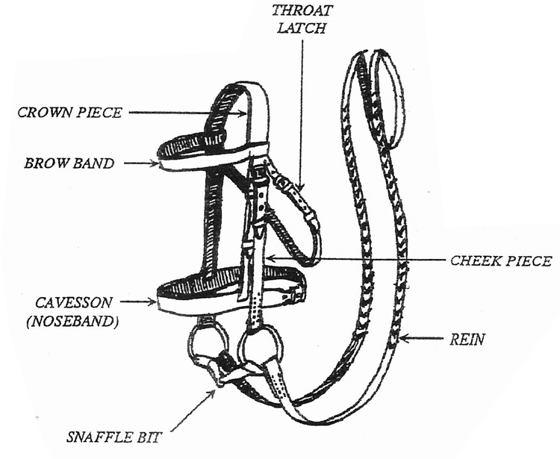

Bridle: The bridle is what is used to help control the horse’s movements and direction when riding. Important parts include the reins, bit, crown piece, cheek piece, and noseband. The reins are what the rider uses when steering. The cheek piece and noseband are two buckles that help secure the bridle. The crown piece goes over the horse’s ears to keep it on while the bit goes into the horse’s mouth. **In the winter, always warm up the bit either with your hands or in your pocket before the horse is bridled.

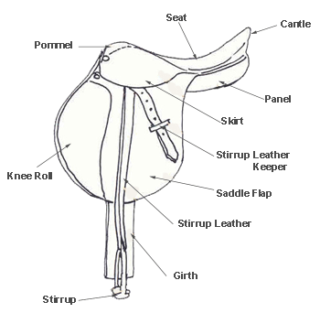
Saddle: The saddle is what we sit in when riding. Important parts of the saddle include the stirrups, girth, and seat. The girth is attached under the horse’s barrel and buckled with the billet straps to prevent the saddle from moving when riding. The stirrups are where the rider puts his/her feet while riding and help to stabilize the leg.
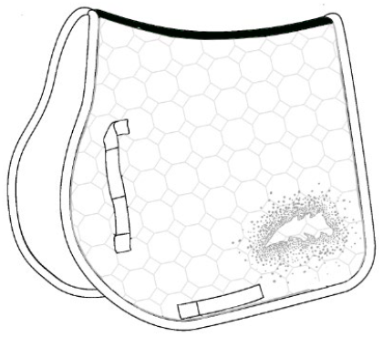
Saddle Pad:
The saddle pad is put between the saddle and the horse to protect from sweat.
Tack room and horse lockers: Each horse has a specific locker where all of its tack and grooming equipment is stored. Each locker in the tack room is labeled with the horse’s name. In addition, all saddles, bridles, and grooming kits also have the horse’s name on it.

Sheets and blankets during colder weather: Each horse has its own sheet and blanket that they wear during colder weather.

Tips and Tricks
- When putting on a sheet or blanket, be aware that the horse could be sensitive to this action and may react to you putting the sheet/blanket on. If this happens, simply go about your business and get the job done.
- Fasten chest straps or closures first when blanketing, then fasten the belly straps. When fastening the belly straps, make sure they are crossed in a “X” shape
- After you finish the front and belly straps, make sure to put the tail over the tail strap to help the blanket stay on.
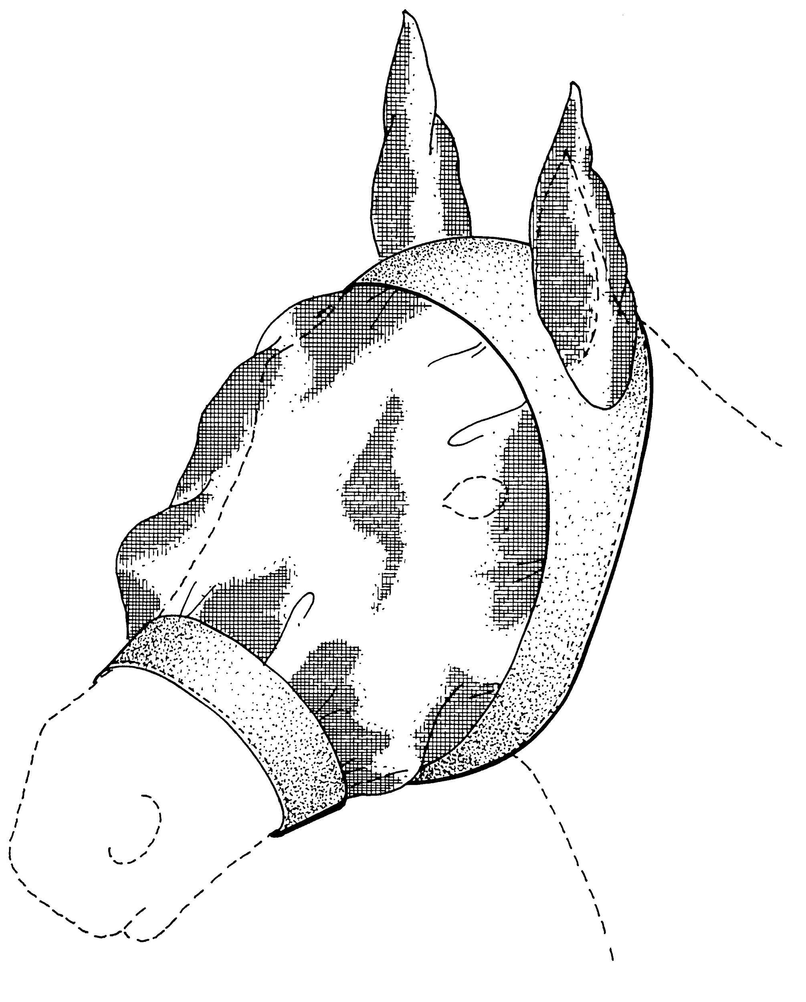
- If you are not sure whether or not to put the blanket or sheet on, ask for assistance from a lead volunteer.

Fly masks and fly spray during warmer weather: During the summer months, the horses have fly masks and fly spray they wear in the field to protect them against bugs. They will be hanging on the horse’s stall door.

Tips and Tricks
- When spraying a horse before a lesson, make sure not to spray the reins or tack because it will weather the tack.
- Always start at the legs when spraying the body so the horse can adjust to the spray on their body and are aware as to what is happening.
- Make sure that the fly mask is UNDER the halter when putting it on for nighttime turnout.
- Any extra tack or equipment such as clean saddle pads, gloves, reins, or riding boots can all be found in their designated areas in the tack room. Ask a leader for assistance.

Wash stall and bathing the horse during warmer weather: During the sunny months when the temperature is hotter and the horses sweat more, we tend to wash them down afterwards to cool them off.

Steps to using the wash stall
- Make sure the horse is securely attached to the crossties in the wash stall before cleaning.
- If they are only slightly sweaty, use a bucket of water and a sponge to sponge them off with water. If they are very sweaty, you may use the hose.
- If using the hose, turn it on away from the horse to adjust water pressure so as not to surprise the horse. Once the stream is a good pressure, begin washing on the legs and work your way up as to not surprise the horse.
- Try to get only the spots where the horse is sweating; the neck, chest, where the girth/saddle was.
- Once fully washed, use a sweat scraper to scrape the excess water off. NEVER put a hot horse right back into the stall.

Lesson Portion of the Program

*Safety is the number one objective: In working with these gentle giants, we need to make sure that both rider and horse are comfortable with the environment. To carry out lessons as safely as possible, there is a leader in charge of handling the horse and sidewalkers to help make sure the rider remains stable.

The Role of A Sidewalker: Sidewalkers are the ones who normally get the most hands-on duties in therapeutic riding. They are directly responsible for the rider. As such, they have the capability to either enhance or detract from the lesson. In the arena, the sidewalker should help the student focus his/her attention on the instructor. Try and avoid unnecessary talking with either the rider or other volunteers. Too much input from too many directions is very confusing to anyone, and to riders who already have challenges, it can be overwhelming. When the instructor gives a direction, allow your student plenty of time to process it. If the instructor says “turn to the right toward me,” and the student seems confused, gently tap the right hand and say, “right,” to reinforce the command. You will get to know the riders and learn when they need help and when they’re just not paying attention.

Sidewalker Guidelines

- Be aware of the rider at all times. Never become so totally relaxed that you are not aware of the rider, horse, leader, instructor, or the activities around you.
- Never walk away from the child while working around the horse. A rider should never be left hanging and always be under supervision.
- Be sure not to lean on the horse or rider since this pressure may unbalance the rider or irritate the horse. It is important to maintain a position by the rider’s knee. Being too far forward or back will make it very difficult to assist with instructions or provide security if the horse should trip or shy.
- When mounting or dismounting, listen to the instructor for the proper support techniques. They can differ vastly with each rider’s needs.

***Never help mount/dismount a student without the instructor present. It is vital to the safety of the rider that the instructor handles all matters related to mounting and dismounting.

- All volunteers are encouraged to talk to the instructor after the sessions regarding any concerns or questions they may have regarding the session. Some issues regarding the clients may not be discussed with volunteers due to confidentiality issues.
- If your arm gets tired from assisting a rider, ask the instructor if you may switch sides with the other sidewalker or request that the instructor step in.

Basic safety holds: During a lesson, to stabilize the rider and keep a safe environment for the horse and the rider, it is important to make sure that the rider has a proper position.

A heel hold: A hold involving stabilizing the rider’s leg by holding down the rider’s ankle and encouraging the rider’s leg to wrap around the horse.

An arm over thigh hold: This is for riders with more physical complications. This helps keep them firmly in the saddle. For this hold, the forearm lies over the thigh and as close to the rider’s hip bone as possible. To keep your arm stable, you may hold onto the pommel of the saddle. Be careful not to dig your elbow into the rider’s thigh or into the horse’s back.

A hand on the hip hold: If a rider is leaning over to one side, a hand on the hip can help keep them in the center of the saddle and straight.

Emergency dismount: Every volunteer is required to learn the emergency dismount before working in a lesson.

Tips and Tricks
- As a sidewalker, you need to be ready to safely dismount an unstable rider. This involves bearing a majority of the weight in your legs (rather than trying to lift a rider with your arms and upper body) and helping to control a rider’s descent to the ground if necessary in an emergency situation.

The Role of the Horse Leader: As a volunteer, one of the most challenging duties you could be assigned is the position of horse leader. A leader’s first responsibility is the horse, but you must also constantly be aware of the rider, instructor, and any potential hazards in or around the arena. In addition, you must also consider the sidewalkers, making sure there is enough room along the fence, and around obstacles for them to pass.

Horse Leader Guidelines

- Make sure the “Y” attachment is attached to the bit BELOW where the reins are attached to the bit.
- An effective leader pays close attention to the rider’s needs as well as to where the horse is going. This attention reinforces the rider’s attempts to control the horse. However, you should not execute an instruction for the rider before he has time to process the information and make an effort to comply. Sometimes it may be appropriate to wait with the horse until the student figures out what to do.
- Avoid the temptation to talk to the rider and/or sidewalkers. A rider may be confused or distracted by too much input.
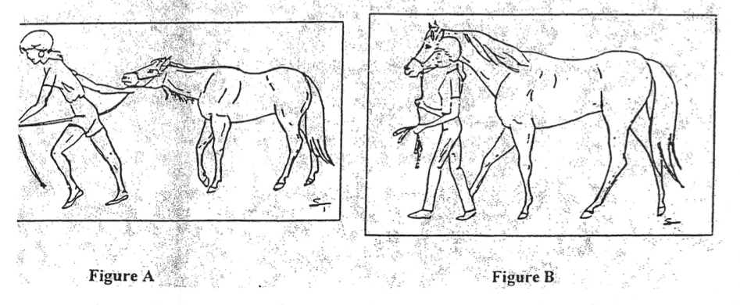
- Figure A depicts a few faults common among leaders. Here is a leader marching along-head down, one hand on the lead rope, the other inside the coiled end of the rope-dragging a strung-out horse. In a battle with a horse, you lose. You must cooperate with the horse. Figure B shows the correct position for leaders. The leadrope is held with the right hand, 6-12 inches from the snap, allowing free motion of the horse’s head. correct position for leaders.

- Talk to the horse; most of them know “whoa,” “walk,” and “trot.” Watch where you’re going and what’s happening around you. DO NOT walk backward to look at the rider. It’s dangerous for everyone and the horse isn’t eager to follow someone who can’t see where he is going.
- Use short tugs rather than a steady pull to keep a lazy horse moving. The horse can set himself against a steady pull, but tugs keep his attention.
- Ensure space is available next to the fence or gate for sidewalkers.
- When you halt for more than a few seconds, stand in front of the horse and loosely hold the lead or reins. Standing in front is a physical barrier to the horse and he will stand more quietly than if he has an easy chance to move out. Don’t put your thumbs through the snaffle or halter rings; they could be broken with a toss of the horse’s head.
- If the worst happens and there is an accident, stay with the horse. There are other people to care for a fallen rider. The situation could easily become more dangerous if there are loose horses running around the arena. Move your horse as far from the fallen student as possible and keep calm. Listen for the instructor’s directions.
- Always make sure that the horse is familiar with the setup and objects in the riding arena. It’s always a good idea to take a few laps around the ring, previous to the lesson, and allow the horse to warm up and to investigate anything he may be unsure of. If the horse is newer to the program, it must be thoroughly socialized to all of the props used in lessons before being used in the program.

What if the horse begins to spook?
The first thing you should do if the horse is scared of something is divert its attention from the object or situation that is alarming him. Follow the instructor’s directions as to where and how to move the horse to maximize safety. into the middle so that if the rider needs to come off, they are coming off in a clear area and away from the fence. Stay calm and try to keep the horse contained until the rider is a safe distance away.

What if there is an obstruction in the way of dismounting?
Occasionally, hazards will pop up that the instructor may be unaware of. For example, if a parent moves in a wheelchair very close to the horse when the horse is halted for dismount, it could be a tripping hazard for the instructor or rider upon descent. Make sure to always alert the instructor of anything that may cause falling or tripping during the dismount so they can be aware of their surroundings and account for all objects on the ground.

Tips and Tricks
- Ys can be found in the tack room on the wall adjacent to the door. Make sure you have the appropriate Y- it varies depending on the horse and bridle.
- Keep a loop in the leadrope to allow the rider as much independence as possible. It is different for every student and some riders are much more independent than others. It is important not to hang on the horse’s mouth for the whole lesson
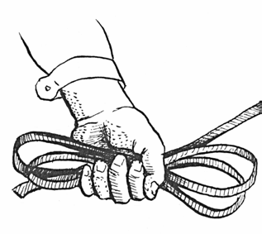
- Figure-8 the leadrope in your hand as opposed to wrapping it around your hand because if the horse spooks, it will fall out of your hand more readily and easily

4. Always lead the horse from the left unless specifically told otherwise.
5. Be aware of input from your sidewalkers regarding the rider and his balance and position and whether the rider is becoming unstable.

Terms Glossary

Aids: Signals that the rider gives the horse
Bareback Pad: A pad that takes the place of a saddle. It is a thin layer between the rider’s body and the horse to help the rider with the movement and stride of the horse
Bend: In relation to the horse shaping his body slightly to the curve or a circle or turn; the response of the horse to bend his body around the rider’s leg
Forehand: The front section of the horse; forelegs, shoulder, neck, and head
Free Walk: A walk on a “loose rein” (long rein) to allow the horse to stretch his neck
Gait: The way of going paces; walk, trot, canter, gallop
Haunches: The hindquarters of a horse
Mattes or Fleece Pad: a small saddle pad where the fuzzy side goes against the horse’s back
Near Side: The left side of the horse
Off Side: The right side of the horse
Posting: “Rising trot,” the rising and descending of the rider with the rhythm of the trot
Y: a leading attachment attached to the bridle that goes on the bit ring in front of where the reins are attached.

